Bennie Case Study on The Connection Between Substance Abuse and Depression
Name
Institutional affiliation

Case overview
Bennie, the character in the case study is an example of the many cases that are illustrative of how drugs and substance abuse can cause depression, withdrawal, and basically suicidal thoughts. The case study does not concentrate so much on the causes of depression but the symptoms that catalyze it. The first symptom of depression was the fact that Bennie had a lot of absent days from work, thus negatively affecting his productivity. Ideally, withdrawal from professional duties either partially or fully without a viable reason such as a warranted medical condition can be assumed to be a symptom of depression in its form. Additionally, the urine screening that reflected positively for cocaine abuse indicated that Bennie was already abusing drugs, which is a common symptom for depression.
Bennie’s depression got worse when he got fired from the construction company that he was working for. Similarly, the initial levels of depression were aggravated by his inability to secure another job or worse still to be able to get involved in any other meaningful activity. The above described is a symptom of depression referred to as diminished interested. Moreover, all the common symptoms of depression as extracted from DSM IV (1994) are witnessed in Bennie’s case. For instance, the case study narrates that Bennie underwent a change in appetite, a situation which saw him lose about 20 pounds in two months. He also appears to feel worthless and has suicidal thoughts. Finally, Bennie’s case study is connotative of situations that elucidate the succinct connection between depression and drugs and substance abuse. In reality, some people find it difficult to establish which comes first, drug and substance abuse or depression. However, the abuse of the substance is causes depression in the order that it can occur when an individual is either high or drunk.
Assessment and Diagnosis
Assessment procedure
The effect and levels of symptoms are paramount in assessing the different level of depressions which can be termed as either mild, moderate or severe. In the interest of the case study, the procedure for assessment should incorporate the following aspects:
- History and examination of the patient – To assess the levels of depression inherent with Bennie, this paper establishes that Bennie has been depressed for two months. Medically speaking, this is enough time for an individual to be declared with a mental disorder which is depression.
- Exploring the functional, interpersonal and or social issues – In the case study presented in the excerpt, it is possible to assess Bennie’s depression as severe based on the functional aspects such as the inability to perform professional duties and absenteeism compounded by drug abuse. Bennie also shows aspects of interpersonal issues when he is seen to have a feeling of unworthiness. His inability to perform anything meaningful with his life surmounts to interpersonal issues related in the case study. In terms of the social aspects, the case study shows that Bennie’s prolonged depressive behavior and drug abuse causes his imminent separation from his long-term girlfriends. As such, it is possible to deduce that depression and abuse of substance and drugs weaken individual social links and, in most cases, causes a breakdown of many relationships among people.
- In assessing psychiatric history, it has already been established that Bennie has been depressed for two months. However, there is no evidence or proof that he has any history of depression or in this respect, a case of mood elevation.
- In assessing patient safety and risk to others, this case study can pinpoint instance where the feeling of unworthiness and self-loathing drove Bennie to have suicidal thought. The aspect of this gist confirms that the level of depression is severe. Evidence-based communication from the case study indicates that Bennie had constant thoughts about death a lot. As such, the patient in the case study is a threat to self with a possibility of inflicting bodily harm or death in worst-case scenarios.
- The last procedure for patient assessment in this case study would be to obtain the medical history from any family members or caregivers. However, this can only be done when due consent is obtained from the patient.
Diagnosis
The formal medical diagnosis for depression utilizes the “Diagnostic and Statistical Manual of Mental Disorders” (DSM IV-TR or DSM-5).
The procedure for diagnosis that I would utilize in the case study is based upon the following metrics.
- Establish the mood of the patient for the better part of the day and or generally every day. The key aspects to check out would be whether the patients feel sad, empty and unworthy for most of the terms. Other aspects that I would watch out for in the case study incorporate the aspects of being tearfully and also whether the patient is in the irritable mood most of the time.
- Establish whether the patient has characteristics of diminished interest or does not find any pleasure in almost every aspect of day to day living. The rationale behind these aspects is embedded in the need to draw behavioral patterns that are resourceful in elucidating whether the patient is depressed or not. It is also a major identifier of the level of depression that the patient is in, in the scale of mild, moderate or severe.
- Establish the health of the patient such as significant weight loss that is not associated without any particular dieting. The rationale behind this procedure is backed up by the theory that pinpoints a loss of more than 5% of an individual mass weight as one of the pivotal checklists for depression.
- Establish whether the patient exhibits any feeling of unworthiness or self-loathing. The guilt of being unproductive and not being able to perform any worthwhile activity for individual development and or progress is a core area of depression. The rationale that backs up this assentation is coined due to the feeling of guilt and sometimes delusion which amount to unworthiness. In most cases, excessive or inappropriate guilty is known as one of the diagnostics of depression cases.
- Establish a case where a patient always feels fatigued and exhausted every day. It is imperative not to confuse this aspect with a case that might be associated with a general medical condition. However, there are tell-tale signs that might associate the feeling of fatigue and exhaustion every day no matter the amount of rest that the individual tries to take.
- Finally, I would try to establish whether the patient has any recurrent thought of death mostly due to the feeling of self-loathing and unworthiness. There are patients who have aspects of suicidal ideation but generally do not have any plans or any designated manner in which they can procure the process.
There exist other methods that can be used to determine depressive episodes in patients but I find the above listed as more viable in this case study.
Analysis of The Pharmacodynamics and Pharmacokinetics of The Substance(S)
As extracted from the case study, the patient (Bennie) is abusing cocaine and drinking heavily. He, therefore, fits the description of the individuals who can be said to be actively involved in substance and alcohol abuse. The following is a Pharmacodynamics and Pharmacokinetics of the substances described above in the case study.
Pharmacodynamics is defined as the amount of drug concentration at the site of the receptor when administered for action in relation to the effects that it bears with aspects of the amount of time consumed, the levels of adverse results and the intensity of therapeutic process needed. The administration of a drug such as cocaine into an individual’s central nervous system prompts an activation and release of rewards component transmitters such as the dopamine. Dopamine is the transmitters in the system that relays the addictive signals of cocaine and similarly causes the high rush and euphoria that is associated with the drug (Negus et al, 2016).
In the case study, as in with the cocaine consumption, there lies an imperative need to understand the channels of the drug administration that also determine the levels of concentrations. The aspect is paramount in establishing the bioavailability and concertation of cocaine in conjunction with key metabolites and effects arising from drugs absorption. The analysis derived in this case study is that effects of the smoked crack cocaine were higher than any other route of administration but though the physiological change was at the same level.
Many researchers have made an attempt to advance the studies on pharmacokinetics and especially on cocaine. However, the available information that relates to the levels of concentration in an individual body in relation to the route of the drug administration remains a contested notion. The above aspect connotes a significant shortcoming especially on the aspects of estimating bioavailability concentration in the human body for cocaine administered using different routes. The following is a simplified analysis of the case:
Table 1. Lookup table for the predicted cocaine peak concentration, the peak time (Prime in min), tb1/2 (in min), and the area under the curve (AUC2∞ in the human brain for a given initial concentration of cocaine with CocE or CocH or endogenous wtBChE in plasma ([E] = 0.035 µM).
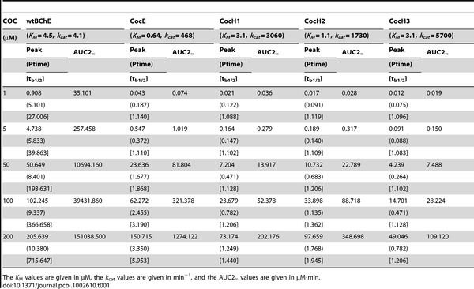
Zheng F, Zhan CG (2012)
Figure 2. A two-compartment model.

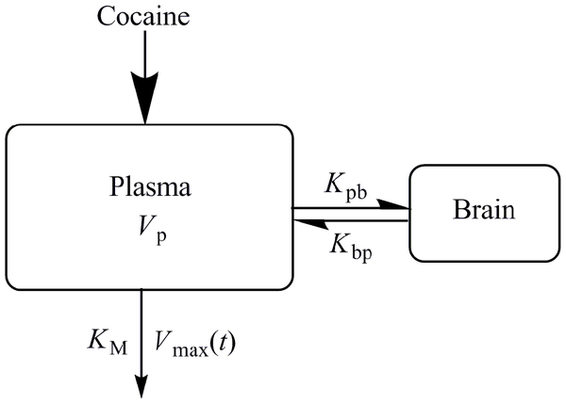
Zheng F, Zhan CG (2012)
When the inhalation of cocaine takes place, its easily absorbed in the lungs and gradually accumulates to the brain through the receptors. When administered through injection, it takes about a full cycle of systematic metabolism and is then extracted through the urine in about four to five hours. In the event that it is detected through screening as it happened with Bennie in the case study in this paper, then it is possible to conclude that the cocaine is unmetabolized and therefore recently administrated into the body.
diagnosis based on the DSM-5’
- The mood of the patient for the better part of the day and or generally every day. Based on the mood, Bennie can be diagnosed with severe depression as he is withdrawn, sad and sullen for the better part of his days as narrated in the case study.
- The patient has characteristics of diminished interest or does not find any pleasure in almost every aspect of day to day living. The rationale behind these aspects is embedded in the need to draw behavioral patterns that are resourceful in elucidating whether the patient is depressed or not. Bennie is unable to secure another job and spends his days in his apartment attempting to watch TV. He is withdrawn and nothing interests him. It is, therefore, possible to conclude that he suffers severe depression
- The health of the patient such as significant weight loss that is not associated without any particular dieting. The rationale behind this procedure is backed up by the theory that pinpoints a loss of more than 5% of an individual mass weight as one of the pivotal checklists for depression. In attribution, Bennie loses about 20 pounds of his total weight. This reflects a severe level of depression.
- The patient exhibits any feeling of unworthiness or self-loathing. The rationale that backs up this assentation is coined due to the feeling of guilt and sometimes delusion which amount to unworthiness. In most cases, excessive or inappropriate guilty is known as one of the diagnostics of depression cases. Bennie is guilty of the fact that his behavior drove away from his girlfriend.
- The patient always feels fatigued and exhausted every day. It is imperative not to confuse this aspect with a case that might be associated with a general medical condition. However, there are tell-tale signs that might associate the feeling of fatigue and exhaustion every day no matter the amount of rest that the individual tries to take. Bennie wakes up exhausted and also finds it very hard to sleep, a case of insomnia. This, however, is a moderate level of depression.
- The patient has recurrent thoughts of death mostly due to the feeling of self-loathing and unworthiness. There are patients who have aspects of suicidal ideation but generally do not have any plans or any designated manner in which they can procure the process. Bennie keeps thinking about death and the ideation of suicide falls in these aspects. Thoughts of death and suicidal ideation can be perceived as severe levels of depression.
How Mental Health Issues In The Case Study Are Exacerbated By Drug Abuse
The case study presented in this analogy has been instrumental in creating a link between mental health issues and drugs. The case study relays a co-occurring disorder where there is the issue of mental health and also a matter of drug addiction. As the case study unfolds, it is established that Bennie has been missing out on work most of the times. The aspects itself is a symptom of depression since it takes away the ability to function in a manner that is productive and even affects how an individual relates to others.
The situation is further aggravated by the facts that the disorders, which includes drug abuse and depression for this case affect each other. Before Bennie tested positive for cocaine screening, it was clear that he already has symptoms of depression which in this instance includes withdrawal from work and abuse. The aspects of losing his job further plunged him into more depression and it got worse. Ideally, it is possible to accentuate that issues to do with mental health coupled with an addiction to drugs and substance abuse are more common than people think.
One question that prompts this discussion is one that inquires on what comes first. Pundits in this study have had an uphill task of correctly relaying information in its utmost accuracy on which comes first between substance abuse and mental health problem (Patel et al, 2016). Drawing excerpts from the case study, it is possible to state that substance abuse might have come first, which is logically the reason why Bennie was fired. However, the dilemma that confronts this type of assentation is the question of what might have prompted the abuse of drugs and substance in the first place. To solve this dilemma, researchers established that drugs and substance abuse are utilized as medication for mental health problems. Thus, it possible to deduce that Bennie must have suffered mental health problems first before he sought the use of cocaine and alcohol.
Etiology
Mental health problems and abuse of drugs and substance in the case might be causative agents for some many things. The first part is biological upon which the health of the individual is at stake (Priester et al, 2016, p.48). Health, in this dimension, is both physiological and mental. The effects of cocaine in the human body are destructive and the same can be said with excessive consumption of alcohol which is known to cause liver cirrhosis. Mental health represents the well-functioning of the brain and might be a big deterrent to proper functioning or even keeping up with relationships with people. Socially, people with depression and mental health problems become withdrawn and would rather be alone. It also creates challenges to the extent that people no longer want to associate with individuals who possess depressive behavior. This solidifies the reason as to why Bennie’s girlfriend left him after she could no longer tolerate his unbecoming behavior.
Psychologically, the aspect of drug abuse and mental health issues sweeps the patient off balance. They are unable to think logically or concentrate on anything. Worse still, these types of patients are haunted by the fact they are no longer reliable as members of the community and thus feel excessive guilt and shame. Additionally, family members are also subjected to psychological trauma when a member of their family is no longer function due to drug abuse and mental health problems.
special needs and treatment recommendations related to dual
diagnosis/co-occurring disorders
the special needs and treatment for the co-occurring disorder is the utility of an integrated approach. This entails a system in which the problem of drug abuse and depression are treating in a simultaneous manner. The reason for the integrated approach is premised on the fact long-recovery of the patient needs taking care of both disorders.
The first treatment is for mental health which incorporates medication, counseling (group or individual), Improved living styles and peer support.
The second treatment is for drugs and substance abuse which entails many things including detoxification, behavioral therapy and support groups among other factors that helps an individual to keep sober.
The special needs for co-occurring disorders in the treatment are that professionals can help in the following:
- Help an individual reflect on the role of drugs in their life’s
- Provide more education about drugs
- Provision of dualistic diagnosis specially molded for people with co-occurring disorders.

Main Techniques for Common Treatment Options for The Case Study Selected
The approach to treatment in the case above is a combination of Cognitive Behavioral detoxification, behavioral therapy, and support groups. the procedure and rationale are best demonstrated in the chart below:
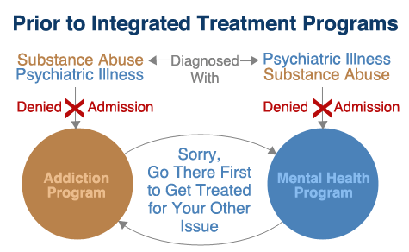
Typical Risk and Protective Factors That Impact the Individual in The Case Study
Typical risks that surround Bennie in the case study are embedded in health. In worst-case scenarios, depression can cause suicide or personal bodily harm. Other than that, one is prone to live a miserable life due to drugs and depression. Consequently, drug abuse can lead to crime, jail or both.
Legal and ethical issues in the case
The legal and ethical issues ensued in the case study can be viewed from different perspectives. The first thing is that drug abuse, especially the use of hard drugs such as cocaine might cause serious legal issues as it’s against the laws of the country. The ethical bit in the case study is the aspect of patient consent when pursuing their medical and family history for any case of depression or mental illness.

References
Negus, S. S., & Banks, M. L. (2016). Pharmacokinetic–Pharmacodynamic (PKPD) Analysis with Drug Discrimination. In The Behavioral Neuroscience of Drug Discrimination (pp. 245-259). Springer, Cham.
Patel, V., Chisholm, D., Parikh, R., Charlson, F. J., Degenhardt, L., Dua, T., ... & Lund, C. (2016). Addressing the burden of mental, neurological, and substance use disorders: key messages from Disease Control Priorities. The Lancet, 387(10028), 1672-1685.
Priester, M. A., Browne, T., Iachini, A., Clone, S., DeHart, D., & Seay, K. D. (2016). Treatment access barriers and disparities among individuals with co-occurring mental health and substance use disorders: an integrative literature review. Journal of substance abuse treatment, 61, 47-59.
Zhan, Z. (2012, July 26). Modeling of Pharmacokinetics of Cocaine in Human Reveals the Feasibility for Development of Enzyme Therapies for Drugs of Abuse. Retrieved from https://journals.plos.org/ploscompbiol/article?id=10.1371/journal.pcbi.1002610

